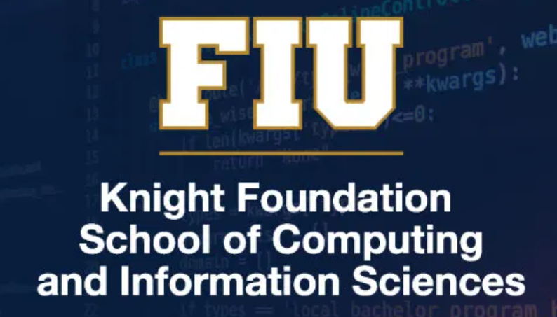

**Undergraduate Peer Assistant Handbook**

**(GRADERS AND TUTORS)**

Knight Foundation School of Computing and Information Sciences

Florida International University

September 16, 2022

**Table of Contents**

1. Welcome 3

1.1. Starting out as a Peer Assistant 3

2. Conduct Expectations 4

2.1. Learning Management Systems 5

2.2. Do not date your students 5

2.3. How to act when you are not “on duty” 5

2.4. FERPA 6

2.5. Advising is for Professionals 6

2.6. What to do if you Suspect Academic Misconduct 6

2.7. Peer Assistant Academic Misconduct 6

3. Grading (Undergraduate TAs only) 7

3.1. Basics 7

3.2. Time Expectations for UTAs 7

4. Learning Assistants (LAs only) 8

4.1. How to help the instructor when giving a test 8

4.2. Time Expectations for LAs 9

4.3. Learning more about teaching 10

5. Tutoring 10

5.1. How to become a STARS or ASI volunteer tutor 10

5.2. How to become a STARS or ASI paid tutor 11

# Welcome

Welcome to the teaching staff of the Knight Foundation School of Computing and Information Sciences (KF-SCIS) at Florida International University (FIU). We appreciate your help in supporting our teaching mission. This document describes some of the available paid peer assistant positions in the school, provides a listing of important policies and procedures, and gives you some suggestions on how to do your job well.

KF-SCIS has many ways for undergraduates to gain paid academic experiences including:

***Tutoring (STARS and ASI):*** These positions enable you to serve outside of the classroom setting as tutors for students. Tutoring can be one-to-one, or sometimes as peer assistant led sessions for small groups in one of our tutoring rooms. The STARS program is advised by Prof. McDermott-Wells, and the ASI program is overseen by Tiana Solis.

***Undergraduate Teaching Assistants (UTAs/Graders):*** Undergraduate Teaching Assistants (Graders) grade assignments under very close supervision of the instructor. Graders are provided with scoring rubrics. Graders do not have direct contact with students that are being graded, and remain anonymous to them.

## Starting out as a Peer Assistant

Peer Assistants must all meet the following requirements:

* Currently enrolled undergraduate majoring in CS or IT; other majors considered on a case-by-case basis
* Overall GPA at least 2.50
* May not have any academic misconducts
* Must pass a background check
* Must be eligible to work in the United States
* May not work a second job on campus beyond a total of 20 hours weekly
* Must have ability to handle both the peer assistant work and your studies

There is an additional requirement to ensure competency in the course that you are serving in:

* Tutors must have earned a grade of “B” or higher in the KF-SCIS course you are serving, or in a subsequent course. For instance, to serve as a tutor in COP2250, you should have earned at least a “B” in COP2250. If you earned a “C” in COP2250, but subsequently earned an “A-“ in COP3804, the “A-“ would satisfy the requirement.
* Graders must having passed the corresponding course with a grade of “B” or higher.
* Tutors must have successfully completed the first two Java programing courses in their CS or IT major with a grade of B or better.

Students who are employed in the STEM Transformation Institute as Learning Assistants (LAs) cannot be assigned grading responsibilities for the same course in the same semester. Similarly, graders may not serve as tutors for the same course in the same semester.

Selection as a UTA requires an interview with KF-SCIS personnel. Undergraduate Graders require weekly meetings, and ongoing communication will occur to ensure adequate training and oversight.

# Conduct Expectations

SCIS undergraduate peer assistants have a position of authority and respect. Such authority and respect comes with a commensurate requirement of responsible use of that authority. Peer assistants serve as leaders and models in the community, and must behave accordingly. This implies:

* In general, each peer assistant should be using his or her position to help create a positive academic environment, where polite and respectful discussion is encouraged.
* Peer assistants, especially tutors, who may have in prior semesters completed some of the assignments in which their students are encountering difficulty must ensure that students do their own work.
* Sharing criticism of students, fellow peer assistants, instructors, etc., with other students, and/or on social media should be avoided. Issues that arise should be referred directly to the instructor.

Penalties for inappropriate behavior will range from a reprimand, to suspension of responsibilities for some period of time, to dismissal from all peer assistance programs, depending on the severity and frequency of the offense.

## Learning Management Systems

Some peer assistants may have access to Learning Management Systems (LMSs, i.e. Canvas) . LMSs and other collaborative spaces, in general, are class resources and should be treated accordingly. You should act professionally at all times on FIU collaborative spaces. This means the use of hostile or abusive messages is not allowed, even if another student offended you. Most importantly, think before you post. Remember that your answer to a question can trigger others to act according to your response. When in doubt, hold off posting until you can confer with the instructor about how to proceed. When employed by SCIS, you are not just another student. You are an employee of the University, so your behavior in a class forum should always be professional.

## Do not date your students

Part of being a peer assistant is that you are also a student and will probably know other students in the class. If you are a learning assistant or a grader, you may not date your students. Please also avoid flirting, being coy, or any other general affair. Involvement with a student over whom you have some power can be construed as harassment. Since you potentially have some control over your students’ grades, you should do nothing that could suggest that anything other than their performance in the class will affect that grade. As a corollary, you should not have a relationship with any of your students prior to the semester starting, as that could be considered a conflict of interest. If you are already dating somebody and they need to take the class, you must let the instructor know about it. Once you inform the instructor, steps will be taken to make sure that do not grade anything for the person you are dating. Please remember that you should not give them inappropriate assistance as a tutor either.

## How to act when you are not “on duty”

You should not discuss the class or students in the class when you are not “on duty.”

## FERPA

The Family Educational Rights and Privacy Act (FERPA) is a federal law requiring that student educational records be maintained confidentially and in privacy. You should never discuss any student’s grades with anyone except the instructor. As a grader, you should be careful to ensure that communications with your instructor are secure (don’t post grades, assuming that only the instructor will have access to retrieve them). Any course related conversations that a student may have with you as a tutor should likewise be kept in confidence and not shared with other students, peer assistants, etc.

## Advising is for Professionals

You must not advise students. Please consider the following:

* Remember that many students may not be in your major, and that degree requirements differ drastically between programs.
* You do not have the resources of advising and cannot possibly give good academic advice to everyone, so please do not do it.
* If students have questions about dropping, please direct them to the instructor. If students have questions about classes to take and pre-requisites, send them to their advisor. Telling students what they should or should not take is not part of your position.

## What to do if you Suspect Academic Misconduct

As a grader, it is likely that at some point you will encounter some submissions that suspiciously resemble one another. The appropriate course of action is as follows:

* Report it to the instructor.
* Afterwards, put it behind you. The instructor will take appropriate action. Please do not mention anything to the student or anyone else about it. Grading should not be conducted any differently. By reporting it, you have done your job.

Please also do not make accusations, notations on the paper, and or take any unilateral action (i.e. emailing the student). Students have a right to a due process that involves the student, the instructor, and the Dean of Students — and not you. Stepping in may deprive the student of his or her rights, yielding possible lawsuits.

If you are a tutor and suspect misconduct, report it to the faculty advisor for the tutoring group. Immediately disassociate with the student you are tutoring, and tell them you cannot work with them if they are copying work, plagiarizing, or cheating in any way.

## Peer Assistant Academic Misconduct

Expect to be treated even more harshly than a University student who is not a peer assistant if you are ever found guilty of academic misconduct. At a minimum, you will be fired with no chance of ever being rehired. We simply cannot have individuals who have violated basic academic fundamentals be involved in helping other students gain an education.

# Grading (Undergraduate TAs only)

Your specific grading tasks will depend on your class. Please be sure to discuss your unique tasks with your instructor.

## Basics

The primary instructor of record must meet with the graders prior to grading any work to discuss and practice implementing a grading rubric. Once past the piloting stage in year one, UTA coordinators may serve as a "hands-on support and guidance" coach as the number of UTAs increases. These individuals will keep the primary instructor informed of each UTA's progress in completing assigned grading tasks and provide feedback to UTAs on their assigned grading tasks. Coordinators can conduct grading calibration sessions for each given assignment.

In general, you will be expected to:

* Grade: Please be responsible and punctual, following deadlines set by the instructor. Grade consistently, rewarding or subtracting the same points for the same work as best possible. Apply any and all criteria stated in a rubric from the instructor. If you have questions about the criteria, please approach the instructor and do not modify the criteria on your own. Where there is flexibility in the criteria, please be consistent and keep notes when you are grading so that you remember why you took points off.
* Communicate with the instructor: Please read and respond to instructor communications within a day’s time.
* Communications with the students: You will be expected to remain anonymous to the students. Students will know nothing beyond the fact that an assignment was graded by someone other than the instructor.
* If in doubt about anything, always ask your instructor how to proceed.

## Time Expectations for UTAs

The expectation is to average 10 hours per week, with a maximum of 12 hours in any one given week.

# Tutoring

ASI tutors are supervised by the KF-SCIS Advising Center, through its Academic Success Initiative (ASI). ASI currently offers undergraduates in KF-SCIS with a GPA lower than 2.0 an academic support experience which assists then in understanding course content while developing self-efficacy.

STARS is a student organization in KF-SCIS that encourages anyone interested in technology to join. Benefits of STARS membership include learning new and different skills, learning tips and techniques for gaining an internship, volunteering in outreach programs to middle and high schools, learning about leadership and mentoring, and making new friends with similar interests. Many STARS members also become STARS tutors. You can learn more about STARS at <http://stars.cis.fiu.edu>.

## How to become a STARS or ASI volunteer tutor

Students who have successfully completed the first two Java programming courses in their CS or IT major with a grade of B or better are eligible to become STARS and ASI tutors.

Prospective STARS tutors must first join the STARS student organization, and then attend a STARS training session held near the beginning of each semester. STARS tutors are required to commit to a fixed weekly schedule. Tutors must log all tutoring encounters with students using the supplied activity log file. A STARS tutor can tutor for any course in which he/she received a grade of B or better. You also must have completed first two programming courses in your major with a B or better, and you must be willing and able to tutor in multiple courses.

## How to become a STARS or ASI paid tutor

STARS and ASI frequently have some paid peer tutoring positions available. For ASI, you must first serve as an ASI volunteer tutor to demonstrate your skills in tutoring. When positions become available, experienced tutors are invited to apply for the positions.

For STARS, you must respond to the invitation to apply that is sent out near the beginning of a semester and complete a registration form. You must attend a mandatory training session.